John Wisner, Jr.
June 26, 1843 – February 17, 1920

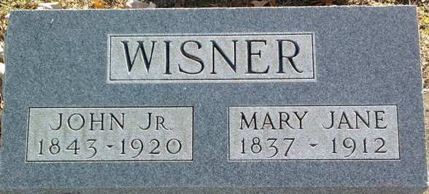
Photo by Thomas Liby

Jenn Wisner Jr
in the Indiana, U.S., Death Certificates, 1899-2017
Name John Wisner Jr
Gender Male
Race White
Marital Status Widower
Age 76
Birth Date 26 Jun 1843
Birth Place Wells County, Indiana
Death Date 17 Feb 1920
Death Place Bluffton, Wells, Indiana, USA
Death Registration Date 1920
Father William M Wisner
Mother Plumer
Spouse Mary Jane Peppard
Informant Family; Bluffton, Indiana
Burial February 19, 1920; Elm Grove Cemetery

