Jennie M. (Masterson) Wisner
April 14, 1865 – June 27, 1949

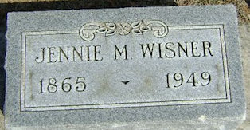
Photo by Bruce Sonner

Jennie M Wisner
in the Indiana, U.S., Death Certificates, 1899-2017
Name Jennie M Wisner
[Jennie M Masterson]
Gender Female
Race White
Marital Status Widowed
Age 84
Birth Date 14 Apr 1865
Birth Place Indiana
Death Date 27 Jun 1949
Death Place Rural, Wells, Indiana, USA
Death Registration Date 1949
Father William Masterson
Mother Maria Perrine
Informant Alfred Wisner; Craigville, Indiana
Burial June 29, 1949; Elm Grove Cemetery; Bluffton, Indiana

