Horace Leland Wisner
February 20, 1853 – July 13, 1919

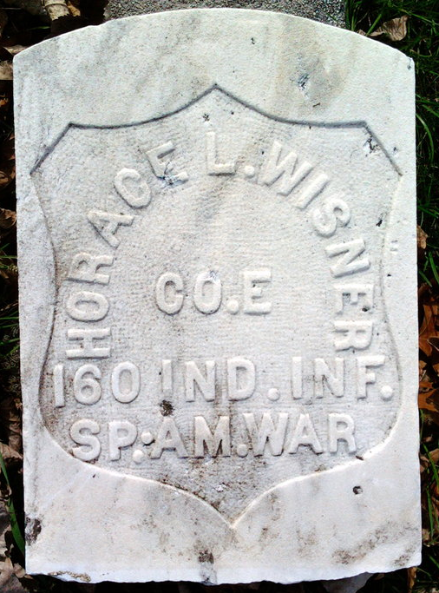
Photo by Thomas Liby

Horas Zeland Wisner
in the Indiana, U.S., Death Certificates, 1899-2017
Name Horas Leland Wisner
Gender Male
Race White
Marital Status Married
Age 66
Birth Date 20 Feb 1853
Birth Place Bluffton, Indiana
Death Date 13 Jul 1919
Death Place Bluffton, Wells, Indiana, USA
Death Registration Date 1919
Father Thomas Wisner
Mother Margaret Shaps
Spouse Aleata Slone
Informant Family; Bluffton, Indiana
Burial July 15, 1919; Elm Grove Cemetery

