Alfred Wisner
January 11, 1891 – October 17, 1964

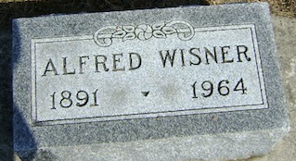
Photo by Bruce Sonner

Alfred Wisner
in the Indiana, U.S., Death Certificates, 1899-2017
Name Alfred Wisner
Gender Male
Race White
Marital Status Married
Age 73
Birth Date 11 Jan 1891
Birth Place Indiana
Death Date 17 Oct 1964
Death Place Bluffton, Wells, Indiana, USA
Death Registration Date 1964
Father Silas Wisner
Mother Jennie Masterson
Informant Mrs. Zola Stewart Wisner; wife; Craigville, Indiana
Burial October 19, 1964; Elm Grove Cemetery; Bluffton, Indiana

