Alethea S. (Sloane) Wisner
June 30, 1867 – December 7, 1958

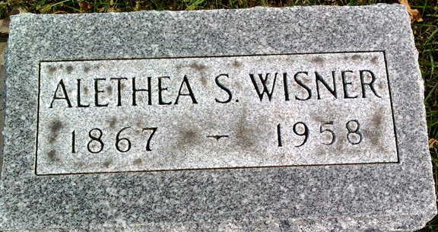
Photo by Thomas Liby

Alothea S. Wisner
in the Kentucky, U.S., Death Records, 1852-1965
Name Alethea S. Wisner
Maiden Name Sloane
Gender Female
Death Age 92
Birth Date 30 Jun 1867
Birth Place Louisville, Kentucky
Death Date 7 Dec 1958
Death Place Pewee Valley, Oldham, Kentucky, USA
Father James Sloane
Mother Elizabeth C. Powell
Informant Mrs. H. T. Wayne
Burial December 9, 1958; Elm Grove Cemetery; Bluffton, Indiana

