Aaron Wisner
July 29, 1846 – May 15, 1922

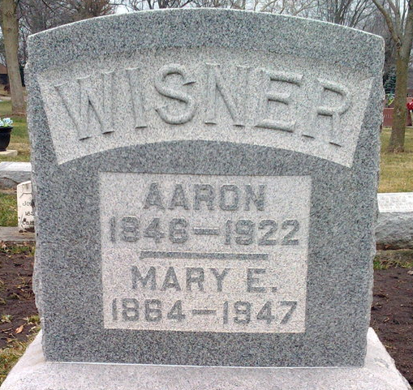
Photo by Thomas Liby

Aaron Wisner
in the Indiana, U.S., Death Certificates, 1899-2017
Name Aaron Wisner
Gender Male
Race White
Marital Status Married
Age 75
Birth Date 29 Jul 1846
Birth Place Wells County, Indiana
Death Date 15 May 1922
Death Place Lancaster, Wells, Indiana, USA
Death Registration Date 1922
Father Aaron Wisner
Mother Sarah Plumer
Spouse Mary Rockwell
Informant Mrs. Aaron Wisner; Bluffton, Indiana
Burial May 17, 1922; Elm Grove Cemetery

