Aaron Wisner
September 30, 1810 – March 1, 1883

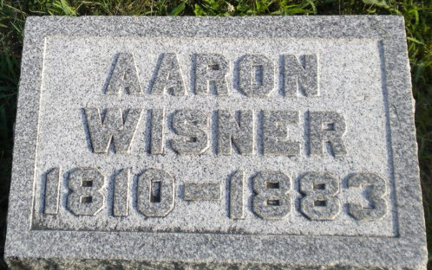
Photo by PLGS

Aaron Wisner from tree Warfield
Birth 30 Sep 1810 Lycoming, Lycoming, Pennsylvania, USA
Marriage 1833 Lycoming, Pennsylvania, USA
Residence 1880 Wells, Indiana, USA
Death 1 March 1883 OR 16 May 1883 Huntington, Huntington, Indiana, USA
Father Benoni "Bennie" WISNER (1764-1828)
Mother Agnes HOOPER (1770-1835)
Spouse Sarah Plummer (1810-1870)

