Kathryn P. (Gross) Wiseley
January 2, 1904 – May 7, 1998

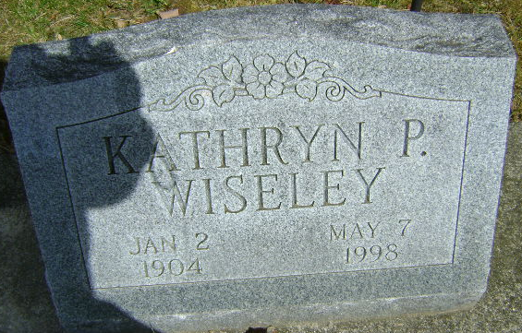
Photo by Bruce Sonner

Kathryn D Wiseley
in the Florida, U.S., Death Index, 1877-1998
Name Kathryn D Wiseley
Race White
Age at Death 94
Birth Date 2 Jan 1904
Death Date 7 May 1998
Death Place Manatee, Florida, United States
**
U.S., Newspapers.com™ Marriage Index, 1800s-current
Name Kathryn Gross
Gender Female
Age 22
Birth Date abt 1904
Residence Date Abt 1926
Residence Place Salinas
Residence Place 2 California
Marriage Date Abt 1926
Spouse Horace Wisely
**
Kathryn G Wisely from tree Rudolph Family Tree
Birth 1904 California, USA
Residence 1950 Salinas, Monterey, California, USA
Father James Henry Gross (Born 1867)
Mother Leila o'lata Carlisle (Born 1875)
Spouse Horace Wiseley (Born 1904)

