Joshua A. Winters
July 27, 1982 – August 3, 2007

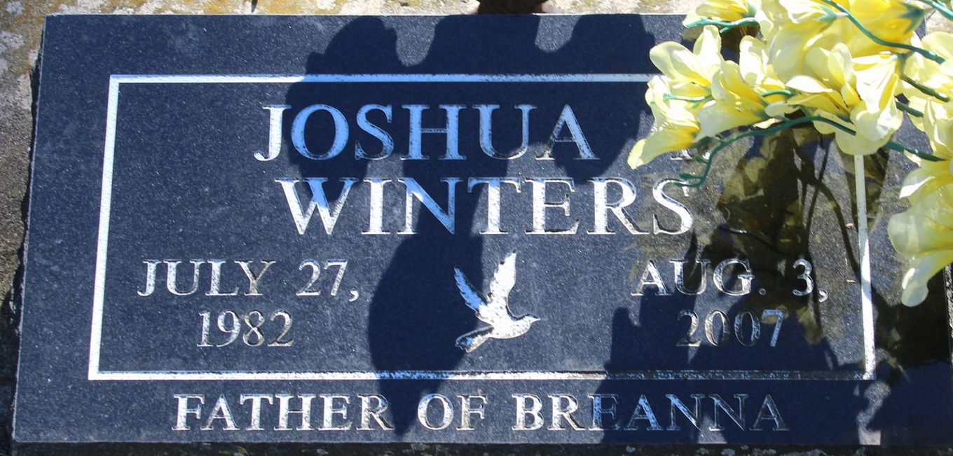
Photo by Tombstoner & Family

Joshua Winters
in the Indiana, U.S., Death Certificates, 1899-2017
Name Joshua Winters
Gender Male
Race White
Marital Status Never Married (Single)
Age 25
Birth Date 27 Jul 1982
Birth Place Wells County, Indiana
Death Date 1 Aug 2007; auto accident
Death Place Fort Wayne, Allen, Indiana, USA
Death Registration Date 2007
Father Joe Compton
Mother April (Kahn) Brandt
Informant April Brandt; mother; Bluffton, Indiana
Burial August 8, 2007; Elm Grove Cemetery; Bluffton, Indiana

