William Wingfield
December 1, 1843 – May 9, 1918

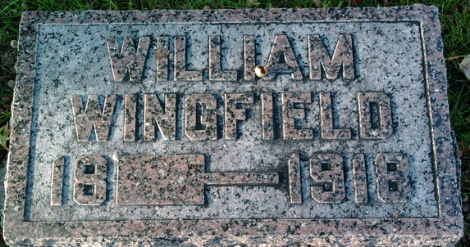
Photo by Thomas Liby

William Wingfield
in the Indiana, U.S., Death Certificates, 1899-2017
Name William Wingfield
Gender Male
Race White
Marital Status Widowed
Age 74
Birth Date 1 Dec 1843
Birth Place Indiana
Death Date 9 May 1918
Death Place Kendallville, Noble, Indiana, USA
Death Registration Date 1918
Father Felix Wingfield
Mother Edith Sinclair
Spouse Charlotte; deceased
Informant ?? Wingfield; Kendallville, Indiana
Burial May 12, 1918; Bluffton, Indiana

