Susan A. (Cemer) Wingfield
April 2, 1854 – October 19, 1917

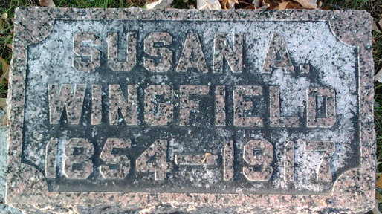
Photo by Thomas Liby

Susan Wingfield
in the Indiana, U.S., Death Certificates, 1899-2017
Name Susan Wingfield
[Susan Cemer]
Gender Female
Race White
Marital Status Married
Age 63
Birth Date 2 Apr 1854
Birth Place Indiana
Death Date 19 Oct 1917
Death Place Kendallville, Noble, Indiana, USA
Death Registration Date 1917
Father Jacob Cemer
Mother Sharlot C. Clark
Spouse William Wingfield
Informant John Wingfield; Kendallville, Indiana
Burial October 21, 1917; Elm Grove Cemetery

