Samuel Edgar Wingfield
July 28, 1871 – July 24, 1943

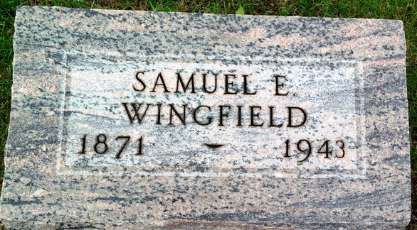
Photo by Thomas Liby

Samuel Edgar Wingfield
in the Michigan, U.S., Death Records, 1867-1952
Name Samuel Edgar Wingfield
Gender Male
Race White
Marital Status Widowed
Death Age 71
Birth Date 28 Jul 1871
Birth Place Wells County Indiana
Death Date 24 Jul 1943
Death Place Sturgis, St Joseph, Michigan, USA
Father William Wingfield
Mother Susan Seamer
Spouse Emma; deceased
Informant Dee Wingfield; Bronson, Michigan
Burial July 26, 1943; Elm Grove Cemetery; Bluffton, Indiana
File Number 005439

