Mary Emma (McConey) Wingfield
February 11, 1874 – March 15, 1921

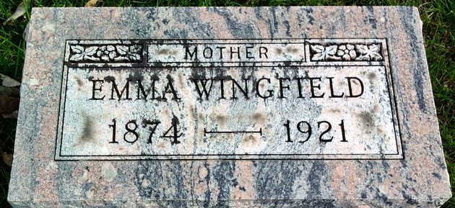
Photo by Thomas Liby

Mary Emma Wingfield
in the Indiana, U.S., Death Certificates, 1899-2017
Name Mary Emma Wingfield
[Mary Emma McConey]
Gender Female
Race White
Marital Status Divorced
Age 47
Birth Date 11 Feb 1874
Birth Place Fayette, Ohio
Death Date 15 Mar 1921
Death Place Bluffton, Wells, Indiana, USA
Death Registration Date 1921
Father Jackson McConey
Mother Mary Leister
Spouse Ed Wingfield
Informant Dee Wingfield; Bluffton, Indiana
Burial March 17, 1921; Elm Grove Cemetery

