Marjorie May Wingfield
October 12, 1912 – December 17, 1912

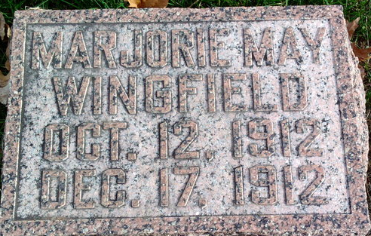
Photo by Thomas Liby

Marjorie May Wingfield
in the Indiana, U.S., Death Certificates, 1899-2017
Name Marjorie May Wingfield
Gender Female
Race White
Marital Status Single
Age 2 months, 8 days
Birth Date 11 Oct 1912
Birth Place Grant County, Indiana
Death Date 17 Dec 1912
Death Place Harrison, Wells, Indiana, USA
Death Registration Date 1912
Father S. E. Wingfield
Mother Mable Grace Dailey
Informant S. E. Wingfield; Bluffton, Indiana
Burial December 19, 1912; Elm Grove Cemetery

