John J. Wingfield
May 14, 1879 – August 19, 1932

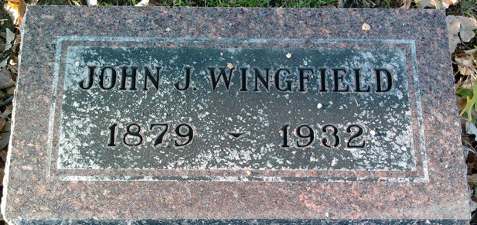
Photo by Thomas Liby

John Wingfield
in the Indiana, U.S., Death Certificates, 1899-2017
Name John Wingfield
Gender Male
Race White
Marital Status Married
Age 53
Birth Date 14 May 1879
Birth Place Indiana
Death Date 19 Aug 1932
Death Place Portland, Jay, Indiana, USA
Death Registration Date 1932
Father William Wingfield
Mother Susan Comer
Spouse Anna L. Forbes
Informant Mrs. John Wingfield; Bluffton, Indiana
Burial August 21, 1932; Elm Grove Cemetery; Bluffton, Indiana

