Edith Louise Wingfield
April 15, 1914 – April 21, 1923

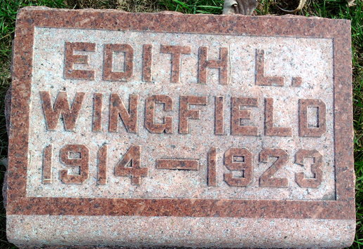
Photo by Thomas Liby

Edith Louise Wingfield
in the Indiana, U.S., Death Certificates, 1899-2017
Name Edith Louise Wingfield
Gender Female
Race White
Marital Status Single
Age 9
Birth Date 15 Apr 1914
Birth Place Indiana
Death Date 21 Apr 1923
Death Place Fort Wayne, Allen, Indiana, USA
Death Registration Date 1923
Father Samuel Wingfield
Mother Grace Daley
Informant John H. Daly
Burial April 24, 1923; Bluffton, Indiana

