Harry Blaine Wiltse
November 6, 1886 – October 24, 1917

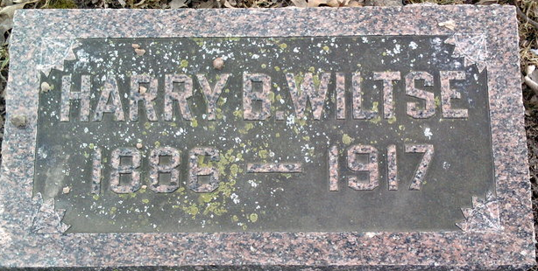
Photo by Thomas Liby

Harry Blaine Wiltse
in the Indiana, U.S., Death Certificates, 1899-2017
Name Harry Blaine Wiltse
Gender Male
Race White
Marital Status Married
Age 30
Birth Date 6 Nov 1886
Birth Place Redkey, Indiana
Death Date 24 Oct 1917
Death Place Indiana, USA
Death Registration Date 1917
Father Charles S Wiltse
Mother Emma Bower
Spouse Emma Weist
Informant C. S. Wiltse; Bluffton, Indiana
Burial October 26, 1917; Elm Grove Cemetery

