Emma (Bower) Wiltse
November 14, 1863 – October 2, 1929

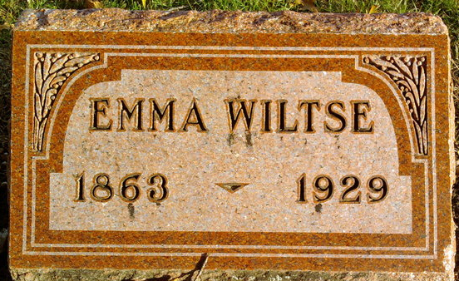
Photo by Thomas Liby

Emma Wiltse
in the Indiana, U.S., Death Certificates, 1899-2017
Name Emma Wiltse
[Emma Bower]
Gender Female
Race White
Marital Status Married
Age 65
Birth Date 14 Nov 1863
Birth Place Wyndotte Co Ohio
Death Date 2 Oct 1929
Death Place Bluffton, Wells, Indiana, USA
Death Registration Date 1929
Father David Bower
Mother Susan Staner
Spouse Chas S Wiltse
Informant C. S. Wiltse; Bluffton, Indiana
Burial October 4, 1929; Elm Grove Cemetery

