Charles Sumner Wiltse
June 8, 1860 – March 2, 1950

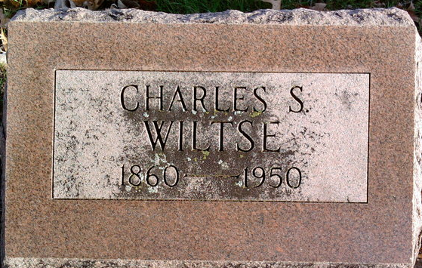
Photo by Thomas Liby

Charles S Wiltse
in the Indiana, U.S., Death Certificates, 1899-2017
Name Charles S Wiltse
Gender Male
Race White
Marital Status Widowed
Age 89
Birth Date 8 Jun 1860
Birth Place Canada
Death Date 2 Mar 1950
Death Place Rural, Wells, Indiana, USA
Death Registration Date 1950
Father Maitland Wiltse
Mother Unknown
Informant Homer Wiltse; Dayton, Ohio
Burial March 4, 1950; Elm Grove Cemetery; Bluffton, Indiana

**
Charles Sumner Wiltse from tree Merth, Brem, Goodman, Lumpkin, Wiltse and others
Birth 8 Jun 1860 Crawford, Ohio, USA
Marriage 26 Nov 1882
Residence 1 Apr 1940 Bluffton, Wells, Indiana, USA
Death 2 Mar 1950 Bluffton, Wells, Indiana, USA
Father Maitland Wiltse (1820-1899)
Mother Magdalena Seery (1822-1861)
Spouse Emma Bower (1863-1929)

