William Sylvester Wilson
December 24, 1866 – June 19, 1939

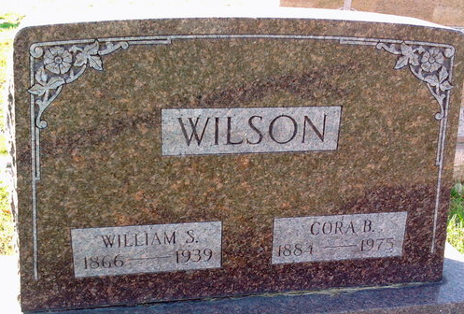
Photo by Thomas Liby

William Wilson
in the Indiana, U.S., Death Certificates, 1899-2017
Name William Wilson
Gender Male
Race White
Marital Status Married
Age 72 years, 5 months, 25 days
Birth Date abt 1867
Birth Place Indiana
Death Date 19 Jun 1939
Death Place Adams, Indiana, USA
Death Registration Date 1939
Father Wilson
Mother Mary Lovell
Spouse Cora
Informant Mrs. Cora Wilson; Geneva, Indiana
Burial June 23, 1939; Bluffton, Indiana
**
Indiana, U.S., Marriages, 1810-2001
Name Wm S Wilson
Gender Male
Event Type Marriage Registration (Marriage)
Marriage Date 3 Nov 1901
Marriage Place Indiana, United States
Mother Mary Loveall
Spouse Cora Brumbaugh
Page 24
FHL Film Number 002318977
**
William Sylvester Wilson from tree Weston Family Tree
Birth 24 Dec 1867 Jay, Indiana, USA
Marriage 3 Nov 1901 Wells, Indiana, USA
Residence 1920 Adams, Indiana, USA
Death 19 Jun 1939 Allen, Indiana, USA
Father Lewis B Wilson (1817-1899)
Mother Mary Lovell (1833-1872)
Spouse Cora Brumbaugh (1884-1975)

