Nancy Jane (Edgell) Sovine-Wilson
February 11, 1950 – August 1, 2015

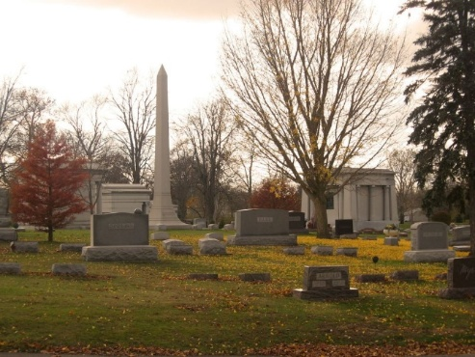
Photo by Tombstoner & Family

Nancy loved to go garage sale shopping; enjoyed computer games; spending time with her grandkids; and her dog Pepper. Nancy collected Barbie's and Kyle Petty merchandise.
Nancy worked in production at CTS in Berne and had previously worked at Hammond's Produce in Decatur.
Surviving are her husband, Tony Wilson of Willshire, OH; daughter, Kristy (Jerry) Geels of Decatur, IN; son, Rick (Emily) Sovine of Decatur, IN; brother, Don (Eldana) Edgell of Decatur, IN; brother, Dick (Rhonda) Edgell of Willshire, OH; sister, Mary (Bob) Brown of Willshire, OH; and 4 grandchildren: Justin Geels; Kylee Geels; Evan Sovine; and Ella Sovine.
Preceding Nancy in death was a son, Jody Ambrose Sovine in infancy; and a brother, Tom Edgell.
Funeral services will be held at 3:00 p.m. Thursday, August 6, 2015 in the Zwick & Jahn Funeral Home, Decatur, Indiana with Kevin Browning officiating. Friends will be received from 1-3 p.m. Thursday, August 6, 2015 in the Zwick & Jahn Funeral Home, Decatur, IN.
Preferred memorials are to CHP Inpatient Hospice Center in Van Wert, Ohio.

Unknown source

**
U.S., Cemetery and Funeral Home Collection, 1847-

Name Nancy J. Wilson
Maiden Name Edgell
Death Age 65
Birth Date 11 Feb 1950
Residence Place Willshire, Ohio
Death Date 1 Aug 2015

**
Indiana, U.S., Marriage Certificates, 1960-2012

Name Nancy Jane Edgell
Gender Female
Marriage Age 17
Birth Date abt 1951
Birth Place Indiana
Marriage Date 10 Feb 1968
Marriage Place Decatur, Indiana Rfd., Adams, Indiana, USA
Marriage Registration Date 1968
Spouse David Walter Sovine
Notes 2 N
Reference Number 1 Bx1453
Reference Number 2 Tr8497
Certificate Number 68 002319
Box Number Box 4

**
Ohio, U.S., Marriage Abstracts, 1970, 1972-2007

Name Nancy J Sovine
Gender Female
Age 49
Birth Year abt 1950
Marriage Date 31 Aug 1999
Marriage Place Ohio, USA
Marriage License Place Van Wert
Residence Place Van Wert
Times Married 1
Spouse Anthony W Wilson
Certificate Number 53193
Volume Number 18347

