Mary Bernadine (Houtz) Wilson
August 11, 1911 – June 18, 1987

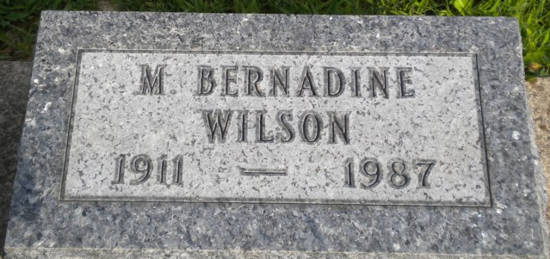
Photo by PLGS

Mary Bernadine Wilson
in the Indiana, U.S., Death Certificates, 1899-2017
Name Mary Bernadine Wilson
[Mary Bernadine Houtz]
Gender Female
Race White
Marital Status Widowed
Age 75
Birth Date 11 Aug 1911
Birth Place Indiana
Death Date 18 Jun 1987; auto/truck accident
Death Place Fort Wayne, Allen, Indiana, USA
Death Registration Date 1987
Father Arthur B H Houtz
Mother Elva Gilliom
Informant James R. Wilson; Monroeville, Indiana
Burial June 21, 1987; Elm Grove Cemetery; Bluffton, Indiana

