Kendell Grace Wilson
February 10, 2012 – February 10, 2012

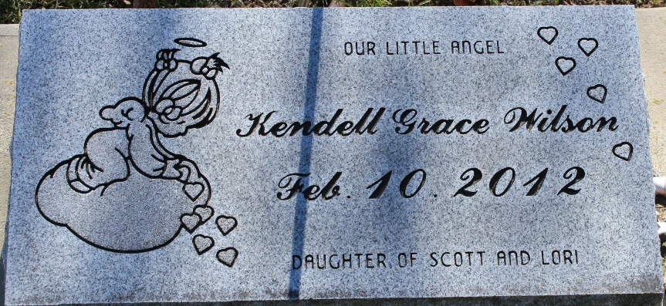
Photo by Tombstoner & Family

Kendell Grace Wilson was stillborn on Friday, February 10, 2012 at Bluffton Regional Medical Center.
She is survived by her parents, Scott Ryan and Lori Ann (Rigby) Wilson of Bluffton, two brothers, Patrick and Zachary Wilson of Bluffton, one sister, Katelin Trissel of Bluffton, grandparents, Ann Rigby of Bluffton, Paul and Marti Wilson of Zanesville, and a great-grandfather, Stan Rigby of Fort Wayne.
She was preceded in death by a grandfather, Tracy Rigby, great-grandparents, Marylin Rigby, Ivory and Gladys Chaffins, Cleo and Lucille Wilson, and Theodore and Esther Grimme.
Calling hours are 5:00 to 7:00 p.m. Tuesday, February 14, 2012 at Thoma/Rich, Chaney & Lemler Funeral Home. Funeral services are at 7:00 p.m. Tuesday at the funeral home with Pastor Timothy McKnight officiating.
Preferred memorials are to Riley Children's Hospital.

Thoma/Rich Funeral Home, Wells County, Indiana
February 11, 2012

