Judith A. (Steffen) Wilson
December 1, 1949 – April 12, 2018

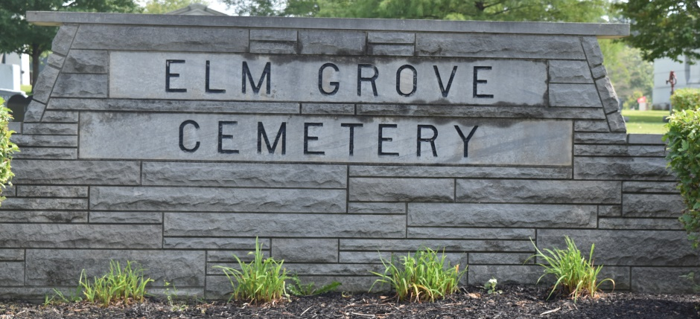
Photo by Bob & Nancy Cannon

Judith A. Wilson, age 68, passed away Thursday, April 12, 2018, at Lutheran Hospital in Ft. Wayne, IN. Judith was born on December 1, 1949 in Bluffton, IN to Willis W. and Bonnie (Andrews) Steffen, both her parents are deceased.
Judith graduated from Bluffton High School in 1968 and worked at Bi – County Services in Bluffton, for 16 years as a Residential Manager.
She is survived by two sons, Gerald L. Wilson II and Chris W. Wilson, both of Bluffton; two brothers, Terry Steffen of Merced, CA and Bruce Steffen of Morton, ILL; and 4 grandchildren.
In addition to her parents, she was preceded in death by a brother, Kevin Steffen.
Funeral services will be held Saturday, April 14, 2018 at 1:00 P.M. at Goodwin – Cale & Harnish Memorial Chapel. Visitation will be Saturday, April 14, 2018, at 11:00 A.M. until service time.
Burial will take place at Elm Grove Cemetery in Bluffton, IN.
Memorials may be made to Bi-County Services Bluffton, IN.
Goodwin Funeral Homes, Wells County, Indiana
April 13, 2018

