Hayden E. Wilson
January 1, 1905 – December 20, 1958

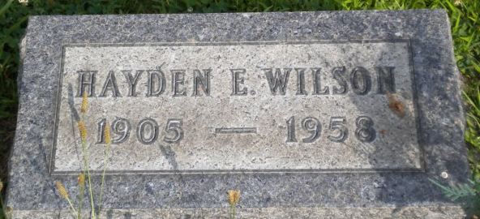
Photo by PLGS

Hayden E Wilson
in the Indiana, U.S., Death Certificates, 1899-2017
Name Hayden E Wilson
Gender Male
Race White
Marital Status Married
Age 53
Birth Date 1 Jan 1905
Birth Place Indiana
Death Date 20 Dec 1958
Death Place South of Ossian, Wells, Indiana, USA
Death Registration Date 1958
Father Rev H Mearl Wilson
Mother Laura Effie Merriman
Informant Mrs. Bernadine Wilson; wife; Fort Wayne, Indiana
Burial December 23, 1958; Elm Grove Cemetery; Bluffton, Indiana

