Fred C. Wilson
December 11, 1889 – October 11, 1972

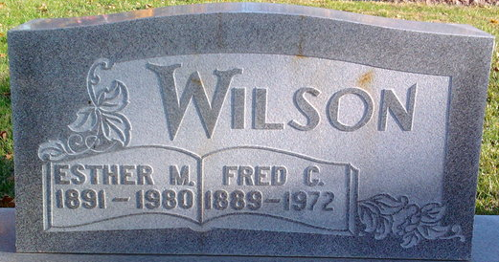
Photo by Thomas Liby

Fred Wilson, 82, a resident of 1127 West South Street died at Wells Community Hospital on Wednesday. Born December 11, 1889, in Bluffton, he was a son of John and Etta Lee Wilson. His marriage to Esther M. Lanning, who survives, took place in Bluffton on June 24, 1909.
Mr. Wilson was a retired railroad worker.
Surviving, in addition to the wife, are a son, Joe F. of Fort Wayne, two grandchildren, and four great-grandchildren.
Services will be at Thoma Funeral Home on Saturday; burial will be in Elm Grove Cemetery.

Wells County, Indiana Obituaries
1969 - 1974

