Esther May (Lanning) Wilson
August 19, 1891 – October 30, 1980

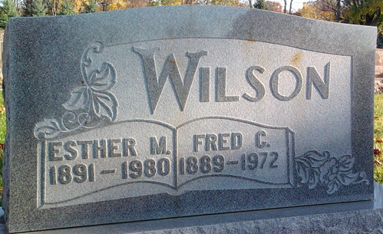
Photo by Thomas Liby

Esther May Wilson
in the Indiana, U.S., Death Certificates, 1899-2017
Name Esther May Wilson
[Esther May Lanning]
Gender Female
Race White
Marital Status Widowed
Age 89
Birth Date 19 Aug 1891
Birth Place Indiana
Death Date 30 Oct 1980
Death Place Bluffton, Wells, Indiana, USA
Death Registration Date 1980
Father Goerge Lanning
Mother Nela Paxson
Informant Rex & Mae Mercer; Bluffton, Indiana
Burial November 1, 1980; Elm Grove Cemetery; Bluffton, Indiana

