Cora Bell (Brumbaugh) Wilson-Ankrom
September 16, 1884 – April 17, 1975

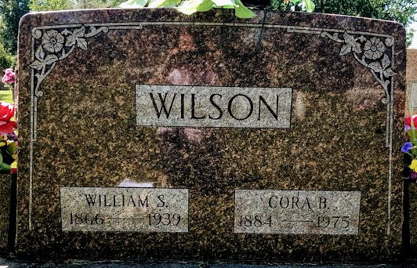
Photo by SMMR

Cora Ankrom
Mrs. Sollie (Cora) B. Ankrom, 90, of route 1, Geneva, died Thursday morning at 10:15 a.m. following an illness of several weeks. She was a member of the Geneva First United Methodist Church, the Geneva Eastern Star, and the Rebeca [sic] Lodge and White Shrine of Portland.
Born September 16, 1884, in Wells County, she was the daughter of John and Jane Kiver-Brumbaugh, and was united in marriage to William Wilson who died June 29, 1939. She later married Sollie Ankrom in October of 1965 and he survives. Also surviving are two daughters, Mrs. Paul (Vergie) Johnson, Sr., of route 3, Bluffton, and Mrs. Garnett (Thelma) Brown of Morristown; one brother, Homer Brumbaugh of Vicksburg, Mich.; four grandchildren, 10 great-grandchildren and three great-great-grandchildren.
Funeral services will be held at 2 p.m. Sunday at the Downing Funeral Home, Geneva, with Rev. Herb Buwalda officiating. Burial will be in the Elm Grove Cemetery, Bluffton. Friends may call at the funeral home after 3 p.m. today.

Decatur Daily Democrat, Adams County, Indiana
Friday, April 18, 1975

