Nova M. Williamson
1894 - 1894

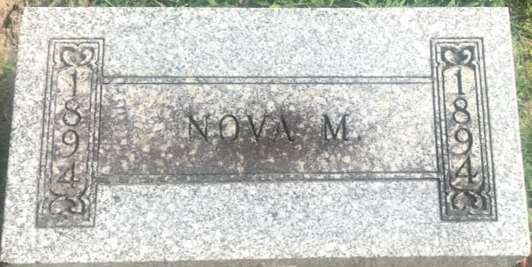
Photo by SMMR

Nova M Williamson from tree STARR and HOLLOWAY Families
Birth 1894 Indiana, USA
Death 1894
Father Myron Ora Williamson (1859-1935)
Mother Emma Jane Carnes (1864-1896)

