Myron Ora Williamson
December 19, 1859 – June 9, 1935

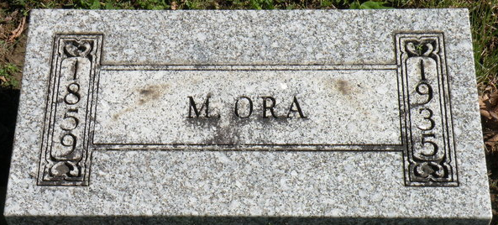
Photo by SMMR

Myron Ora Williamson
in the Indiana, U.S., Death Certificates, 1899-2017
Name Myron Ora Williamson
Gender Male
Race White
Marital Status Widowed
Age 75
Birth Date 19 Dec 1859
Birth Place Indiana
Death Date 9 Jun 1935
Death Place Chester, Wells, Indiana, USA
Death Registration Date 1935
Father Benjiman Williamson
Mother Sarah Layton
Spouse Emma Jane Carnes
Informant Dr. Erman Williamson; Keystone, Indiana
Burial June 11, 1935; Elm Grove Cemetery

