Mearl K. Williamson
February 28, 1883 – January 17, 1925

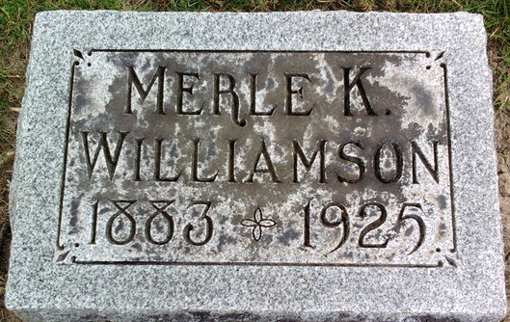
Photo by SMMR

Merl K Willaimson
in the Indiana, U.S., Death Certificates, 1899-2017
Name Merl K Williamson
Gender Male
Race White
Marital Status Married
Age 41
Birth Date 28 Feb 1883
Birth Place Bluffton, Indiana
Death Date 17 Jan 1925
Death Place Bluffton, Wells, Indiana, USA
Death Registration Date 1925
Father George Williamson
Mother Annie E Kiger
Spouse Florence Wandel
Informant Mrs. M. K. Williamson; Bluffton, Indiana
Burial January 20, 1925; Elm Grove Cemetery

