Mearl D. Williamson
December 2, 1895 – March 11, 1939

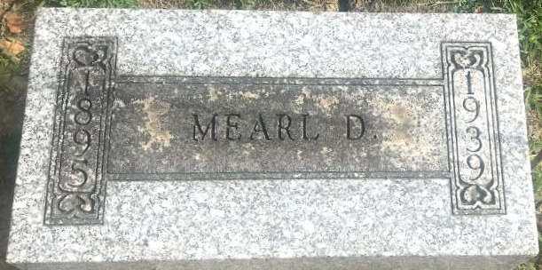
Photo by SMMR

Marle Williamson
in the Indiana, U.S., Death Certificates, 1899-2017
Name Merle Williamson
Gender Male
Race White
Marital Status Single
Age 42
Birth Date 2 Dec 1895
Birth Place Indiana
Death Date 11 Mar 1939; suicide
Death Place Chester, Wells, Indiana, USA
Death Registration Date 1939
Father Myron O Williamson
Mother Emma J. Carnes
Informant ?. C. Williamson; Montpelier, Indiana
Burial March 13, 1939; Elm Grove Cemetery

