Mabel (Warner) Williamson
October 27, 1878 – March 2, 1959

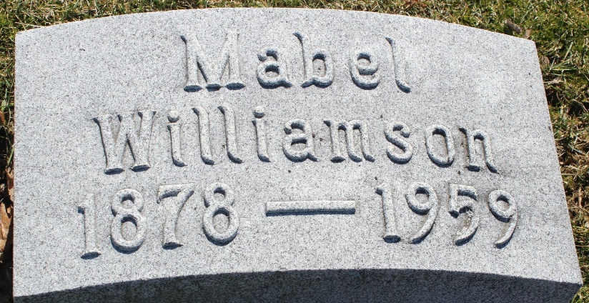
Photo by Tombstoner & Family

Mable Williamson
in the Indiana, U.S., Death Certificates, 1899-2017
Name Mable Williamson
[Mable Warner]
Gender Female
Race White
Marital Status Married
Age 80
Birth Date 27 Oct 1878
Birth Place Indiana
Death Date 2 Mar 1959
Death Place Montpelier, Blackford, Indiana, USA
Death Registration Date 1959
Father Cyrene Warner
Mother Mary Jane Bassett
Informant Dwight K. Williamson; husband; Bluffton, Indiana
Burial March 5, 1959; Elm Grove Cemetery; Bluffton, Indiana

