Lent A. Williamson
December 8, 1845 – December 21, 1914

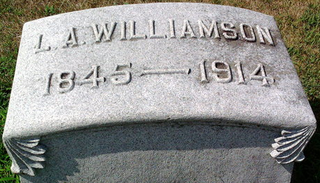
Photo by Thomas Liby

BLUFFTON NEWS (Special Correspondence)

E. B. Williamson received a telegram Monday afternoon telling of the death of his father, L. A. Williamson, in Ocean Park, Cal., where he and his wife went two weeks ago to spend the winter. Mr. Williamson was taken ill with bronchial pneumonia, following his arrival in Ocean Park, and was in a serious condition for over a week. A message Sunday stated that he had passed through the crises of his sickness, but that he was very weak.
The news of Mr. Williamson’s death came as a shock to Wells County residents. He was one of the most prominent men in the county and held several responsible business positions. Mr. Williamson was president of the Wells County Bank, auditor of Wells County, vice-president and director of the M. & B. Traction Company, director of the B., B. & C. Traction Company, director of the Union Savings & Trust Company, director and treasurer of the Peoples’ Mutual Savings Company, and treasurer of the Elm Savings Company, and treasurer of the Elm Grove Cemetery Company.
He is survived by the wife, a daughter, Mrs. Earl Merriman, of Indianapolis; and three sons, Paul, of Attica; Bruce and Dwight Williamson, of this city. Several sisters also survive.
The body was started on the way to this city Sunday and will arrive here in three days.
Unknown source
**
California, U.S., Death Index, 1905-1939
Name Lent A Williamson
Birth Year abt 1845
Death Date 21 Dec 1914
Age at Death 69
Death Place Los Angeles, California, USA

**
Alonzo Wesley "Lent" Williamson from tree Bolenbaugh Family Tree
Birth 8 Dec 1845 Fairfield, Ohio, USA
Marriage 6 Sep 1875 Ohio, USA
Residence 1900 Wells, Indiana, USA
Death 22 Dec 1914 Los Angeles, Los Angeles, California, USA
Father Jacob Prather Williamson (1804-1876)
Mother Eliza Ann Odell (1807-1894)
Spouse Dorothea Kellerman (1848-1925)

