Jesse H. Williamson
November 1, 1884 – October 9, 1964

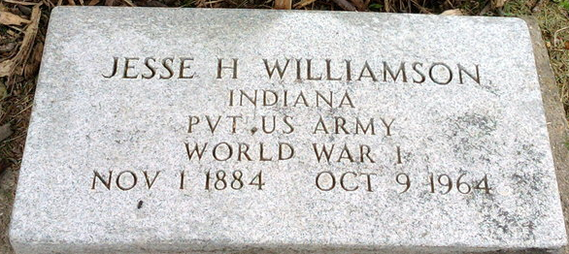
Photo by Thomas Liby

Mr Jesse H Williamson
in the Indiana, U.S., Death Certificates, 1899-2017
Name Mr Jesse H Williamson
Gender Male
Race White
Marital Status Widowed
Age 79
Birth Date 1 Nov 1884
Birth Place Indiana
Death Date 9 Oct 1964
Death Place Bluffton, Wells, Indiana, USA
Death Registration Date 1964
Father George J Williamson
Mother Anna Kiger
Informant Hospital chart
Burial October 11, 1964; Elm Grove Cemetery; Bluffton, Indiana

