Florence (Wandel) Williamson
August 6, 1895 – June 1, 1963

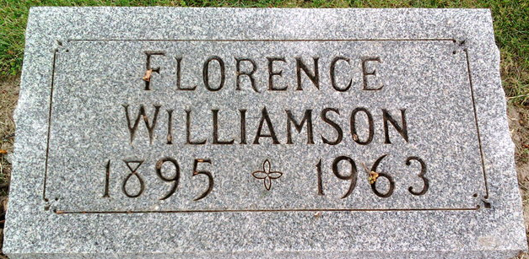
Photo by Thomas Liby

Florence Williamson
in the Indiana, U.S., Death Certificates, 1899-2017
Name Florence Williamson
[Florence Wandel]
Gender Female
Race White
Marital Status Married
Age 67
Birth Date 6 Aug 1895
Birth Place Indiana
Death Date 1 Jun 1963
Death Place Bluffton, Wells, Indiana, USA
Death Registration Date 1963
Father Adalgo Wandel
Mother Nellie Clayton
Informant Jesse H Williamson; husband; Bluffton, Indiana
Burial June 2, 1963; Elm Grove Cemetery; Bluffton, Indiana

