Dr. Erman C. Williamson
May 23, 1891 – March 30, 1941

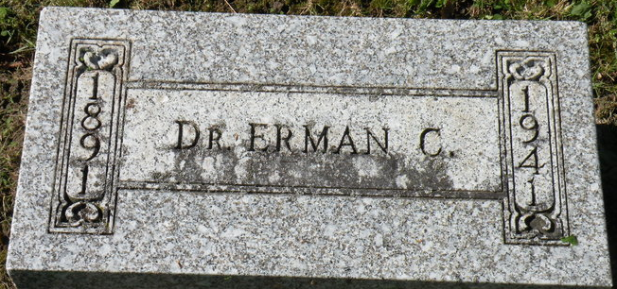
Photo by SMMR

Erman C Williamson
in the Indiana, U.S., Death Certificates, 1899-2017
Name Erman C Williamson
Gender Male
Race White
Marital Status Married
Age 49
Birth Date 23 May 1891
Birth Place Wells County, Indiana
Death Date 30 Mar 1941
Death Place Rural, Wells, Indiana, USA
Death Registration Date 1941
Father Myron C Williamson
Mother Emma J Carnes
Spouse Ethel Wood
Informant Mrs. Ethel Williamson; Montpelier, Indiana
Burial April 3, 1941; Elm Grove Cemetery; Bluffton, Indiana

