Emma Jane (Carnes) Williamson
May 6, 1864 – July 21, 1896

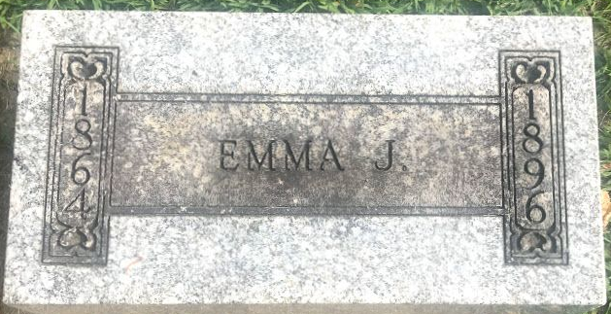
Photo by SMMR

Emma Jane Carnes from tree William Henry Carnes Family Tree
Birth 6 May 1864 Wells, Indiana, USA
Residence 1880 Wells, Indiana, USA
Marriage 14 Mar 1890 Bluffton, Wells, Indiana, USA
Death 21 Jul 1896 Wells, Indiana, USA
Father Robert W Carnes (1834-1907)
Mother Margaret Murray (1841-1915)
Spouse Myron Williamson (1859-1935)

