Dwight Warner Williamson
July 2, 1913 – July 26, 1937

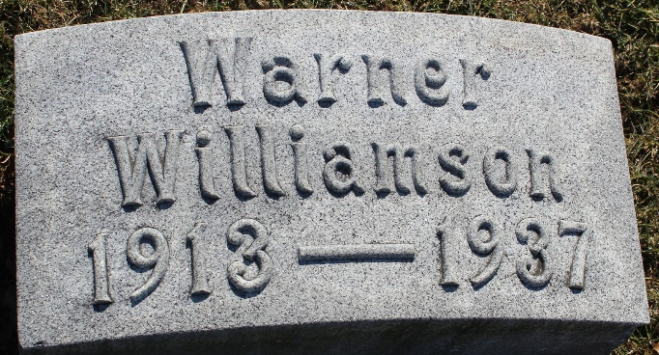
Photo by Tombstoner & Family

Dwight Warner Williamson
in the Indiana, U.S., Death Certificates, 1899-2017
Name Dwight Warner Williamson
Gender Male
Race White
Marital Status Single
Age 24
Birth Date 2 Jul 1913
Birth Place Indiana
Death Date 26 Jul 1937; polio
Death Place Muncie, Delaware, Indiana, USA
Death Registration Date 1937
Father Dwight Kellerman Williamson
Mother Mabel Warner
Informant Mother; Bluffton, Indiana
Burial July 28, 1937; Bluffton, Indiana

