Dwight K. Williamson
July 23, 1879 – June 10, 1977

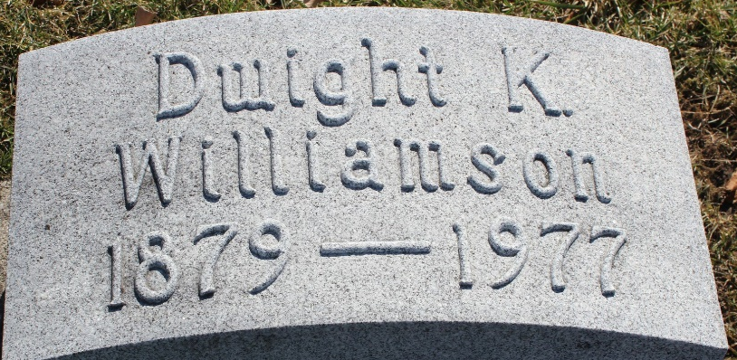
Photo by Tombstoner & Family

Dwight K. Williamson
in the Indiana, U.S., Death Certificates, 1899-2017
Name Dwight K. Williamson
Gender Male
Race White
Marital Status Widowed
Age 97
Birth Date 23 Jul 1879
Birth Place Indiana
Death Date 10 Jun 1977
Death Place Bluffton, Wells, Indiana, USA
Death Registration Date 1977
Father L A. Williamson
Mother Dorothea Kellerman
Informant Hospital chart
Burial June 13, 1977; Elm Grove Cemetery; Bluffton, Indiana

