Dorothea K. (Kellerman) Williamson
January 24, 1848 – October 8, 1928

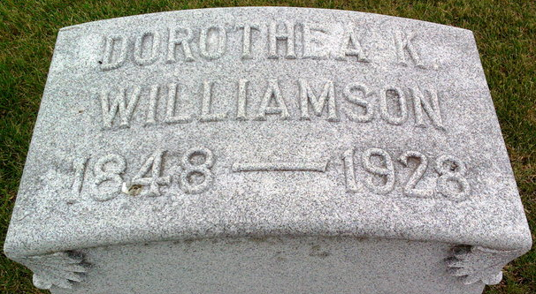
Photo by Thomas Liby

Dorothea K Williamson
in the Indiana, U.S., Death Certificates, 1899-2017
Name Dorothea K Williamson
[Dorothea K Kelleman]
Gender Female
Race White
Marital Status Widow
Age 79
Birth Date 24 Jan 1849 [sic]
Birth Place Fairfield County, Ohio
Death Date 8 Oct 1928
Death Place Bluffton, Wells, Indiana, USA
Death Registration Date 1928
Father Daniel K Kelleman
Mother Ivy Ashbrook
Spouse Lent A Williamson
Informant Bruce Williamson; Bluffton, Indiana
Burial October 11, 1928; Elm Grove Cemetery

