Robert B. Williams
January 17, 1905 – July 25, 1982

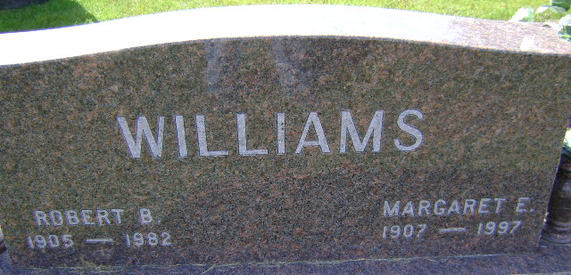
Photo by Bruce Sonner

Robert B. Williams
in the Indiana, U.S., Death Certificates, 1899-2017
Name Robert B. Williams
Gender Male
Race White
Marital Status Married
Age 77
Birth Date 17 Jan 1905
Birth Place Indiana
Death Date 25 Jul 1982
Death Place Bluffton, Wells, Indiana, USA
Death Registration Date 1982
Father Frank R. Williams
Mother Pearl Ball
Spouse Margaret E. Gable
Informant Mrs. Margaret E. Williams; Bluffton, Indiana
Burial July 28, 1982; Elm Grove Cemetery; Bluffton, Indiana

