Nellie D. (Johnson) Williams
September 9, 1889 – February 27, 1954

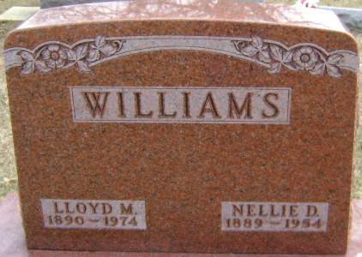
Photo by Bruce Sonner

Nellie D Williams
in the Indiana, U.S., Death Certificates, 1899-2017
Name Nellie D Williams
[Nellie D Johnson]
Gender Female
Race White
Marital Status Married
Age 64
Birth Date 9 Sept 1889
Birth Place Indiana
Death Date 27 Feb 1954
Death Place Bluffton, Wells, Indiana, USA
Death Registration Date 1954
Father Walter B Johnson
Mother Dora Belle Mettler
Informant Lloyd Williams; Bluffton, Indiana
Burial March 1, 1954; Elm Grove Cemetery; Bluffton, Indiana

