Margaret E. (Gable) Williams
February 25, 1907 – May 15, 1997

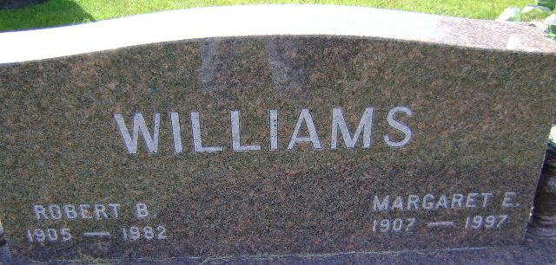
Photo by Bruce Sonner

Margaret E. Williams
in the Indiana, U.S., Death Certificates, 1899-2017
Name Margaret E. Williams
[Margaret E. Gable]
Gender Female
Race White
Marital Status Widowed
Age 90
Birth Date 25 Feb 1907
Birth Place Richmond, Indiana
Death Date 15 May 1997
Death Place Bluffton, Wells, Indiana, USA
Death Registration Date 1997
Father Charles Ernest Gable
Mother Bessie Casteel
Informant Thomas Williams; son; Bluffton, Indiana
Burial May 19, 1997; Elm Grove Cemetery; Bluffton, Indiana

