Lloyd M. Williams
May 23, 1890 – October 10, 1974

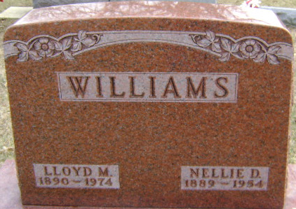
Photo by Bruce Sonner

Lloyd Williams, 84, of 211 West Wabash Street died Thursday at Davis Nursing Home. A son of Clark and Thelma Manston Williams, he was born May 23, 1890, in Champaign, Illinois. His marriage, July 30, 1955, in Bluffton was to Elizabeth Poffenberger who preceded him in death in April of 1966.
Surviving is a stepdaughter, Mrs. Robert (Esther) Lautzenheiser of Bluffton, nieces, and nephews.
Services will be held Saturday at Thoma/Rich Funeral Home with burial in Elm Grove Cemetery.

Wells County, Indiana Obituaries
1969 - 1974

