Helen L. (Downen) Williams
February 2, 1931 – August 21, 1967

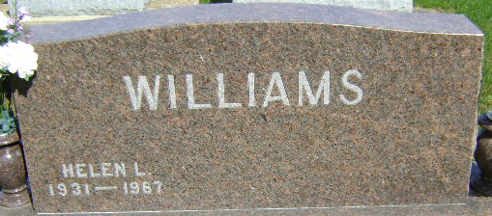
Photo by Bruce Sonner

Helen E Williams
in the Indiana, U.S., Death Certificates, 1899-2017
Name Helen E Williams
[Helen E Downen]
Gender Female
Race White
Marital Status Married
Age 36
Birth Date 2 Feb 1931
Birth Place Indiana
Death Date 21 Aug 1967
Death Place Bluffton, Wells, Indiana, USA
Death Registration Date 1967
Father Frank Downen
Mother Inez Hogue
Informant Thomas Williams; husband; Bluffton, Indiana
Burial August 23, 1967; Elm Grove Cemetery; Bluffton, Indiana

