Charles Wayne Williams
April 5, 1906 – February 2, 1993

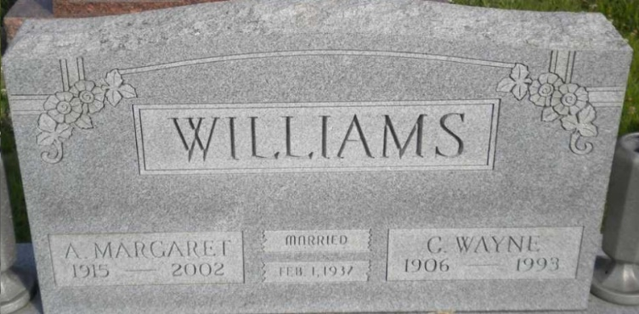
Photo by PLGS

Charles Wayne Williams
in the Indiana, U.S., Death Certificates, 1899-2017
Name Charles Wayne Williams
Gender Male
Race White
Marital Status Married
Age 86
Birth Date 5 Apr 1906
Birth Place Enfield, Illinois
Death Date 2 Feb 1993
Death Place Bluffton, Wells, Indiana, USA
Death Registration Date 1993
Father William O Williams
Mother Edith Faye Fisher
Spouse Anna Johnson
Informant Anna Williams; wife; Bluffton, Indiana
Burial February 5, 1993; Elm Grove Cemetery; Bluffton, Indiana

