Anna Margaret (Johnson) Williams
June 25, 19154 – December 30, 2002

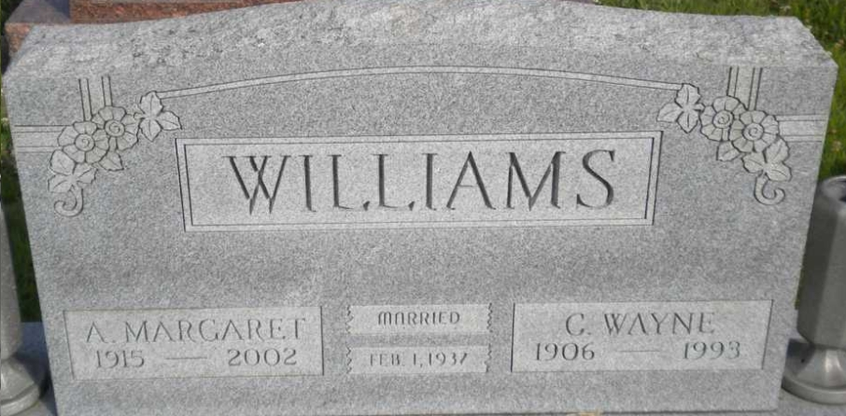
Photo by PLGS

Margaret Williams, 87, who was employed at the Progress in Bluffton for 12 years, died at 5:30 pm Monday, December 30, at Ossian Health Care.
The former Bluffton resident had lived at 735 West Townley Street. She was born in Piper City, Illinois June 25, 1915, a daughter of Lars and Dora Vogelbacher Johnson. Her marriage on February 1, 1937 at Paxton, Illinois was to Charles “Wayne” Williams, who died February 2, 1993.
Surviving are a son, Richard W. Williams of Fort Wayne; four daughters, Mrs. Tino (Doris) Martinez of Huntington Park, California, Shirley Miller of Marion, Mrs. Jerome (Melissa) Newman of Poneto and Mary Kizer of Bluffton; two brothers, Joseph E. Johnson of New Lenox, Illinois and A. Lavern Johnson of Piper City, Illinois; 11 grandchildren; 14 great grandchildren and two great-great grandchildren. Two sisters are deceased.
Services at 10:30 am Friday will be at Goodwin Memorial Chapel in Bluffton with Rev. Rick Bourne officiating. Burial will be in Elm Grove Cemetery. Visitation hours will be Thursday from 2 to 8 pm at the Goodwin Chapel.
Memorials to Hospice of Northeast Indiana at Fort Wayne.

Bluffton News Banner, Wells County, Indiana
December 31, 2002

