Virginia C. (Harvey) Willey
July 4, 1923 – October 13, 2006

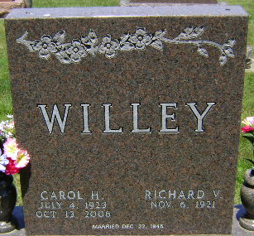
Photo by Bruce Sonner

Carol H. Willey, 83, a lifelong resident of Bluffton and a dedicated volunteer with many public services, died unexpectedly of natural causes at 7:53 p.m. Friday, Oct. 13, 2006 at Bluffton Regional Medical Center.
Born on July 4, 1923 in Bluffton to Earl and Bernice (Masterson) Harvey, she was a graduate of Bluffton High School in 1941. Her marriage on Dec. 22, 1946 was to Richard Willey, who survives.
Also surviving are four daughters, Mrs. Kenneth (Sylvia) Clark of Alexandria; Mrs. Douglas (Sally) Halberstadt of Bluffton; Mrs. Daniel (Cindy) Leininger of Warsaw and Mrs. Michael (Sarah) Gotsch of South Bend. Also surviving are 14 grandchildren and five great grandchildren.
Mrs. Willey retired in 1985 from NIPSCO, where she worked as an executive assistant for 17 years. She also worked as the secretary to the superintendent of Bluffton schools from 1941 to 1947.She was an active member of the First United Methodist Church for more than 50 years, serving as a member of the finance and bereavement committees as well as with numerous other committees.
She was an active volunteer at the Wells County Food Bank, Wells County Public Library, and Bluffton Regional Medical Center. She was also an active member of Tri Kappa Sorority, where she served on various committees.In 2002, Mrs. Willey was the Bluffton Business and Professional Women's "Volunteer of the Year" and was recognized as a "perfect example of a person living the Golden Rule."
Services for Mrs. Willey will be at 11:30 a.m. Wednesday at First United Methodist Church with Pastor Cindy Osgood officiating. Visitation will be from 2 to 8 p.m. Tuesday at Thoma/Rich, Hewitt & Chaney Funeral Home and from 10 a.m. until time of services on Wednesday at the church. A Tri Kappa Memorial Service will be held at 8 p.m. Tuesday at the funeral home. Burial will be at Elm Grove Cemetery.
Memorial contributions may be made to the First United Methodist Church.

Thoma/Rich Funeral Home, Wells County, Indiana
October 14, 2006

