Tate Camden Willey
September 8, 1992 – November 27, 2016

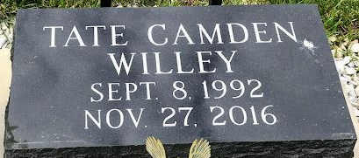
Photo by SMMR

Tate Camden Willey passed away on Sunday, November 27, 2016 in Celina, Ohio. Tate was born on September 8, 1992 in Wells County to Donald L. and Devon (Poindexter) Willey.
He graduated from Coldwater High School in 2011 and earned his B.S in Informational Technology with a minor in Business Administration from Ball State University. He was currently working as an I.T. Tech. for North Adams Schools in Decatur.
He will always be remembered by his family, especially his parents Donald and Devon of Celina, Ohio and his brother Carson (wife Katie) Willey of Silver Springs, Maryland, grandparents, Dr. and Mrs. B.K. & Patty Poindexter of Bluffton and uncles Clay (Joan) Poindexter and Blake (Lauriean) Poindexter, both of Bluffton and an aunt, Gay (Barry) Willits of Scottsdale, Arizona.
Private family services have been held for Tate with Pastor Steve Bard officiating. Burial followed in Elm Grove Cemetery in Bluffton.
Thoma/Rich Funeral Home, Wells County, Indiana
November 28, 2016

